#1
CMS-1105

Tumescent Hand Pump Set

Bill of Materials Quantity
T0163 .114” x .159” 108” length (1)
M0044 White slide clamp 1
M0200 Universal Spike 1
A0240 Panneri-Cohesive tape 1
M0678 Control Syringe with spring 1
M0517 Bulk dual check valve with female luer slip 1
A0050 8*12 Tyek Chevron pouch 1

10 Sets Per Case
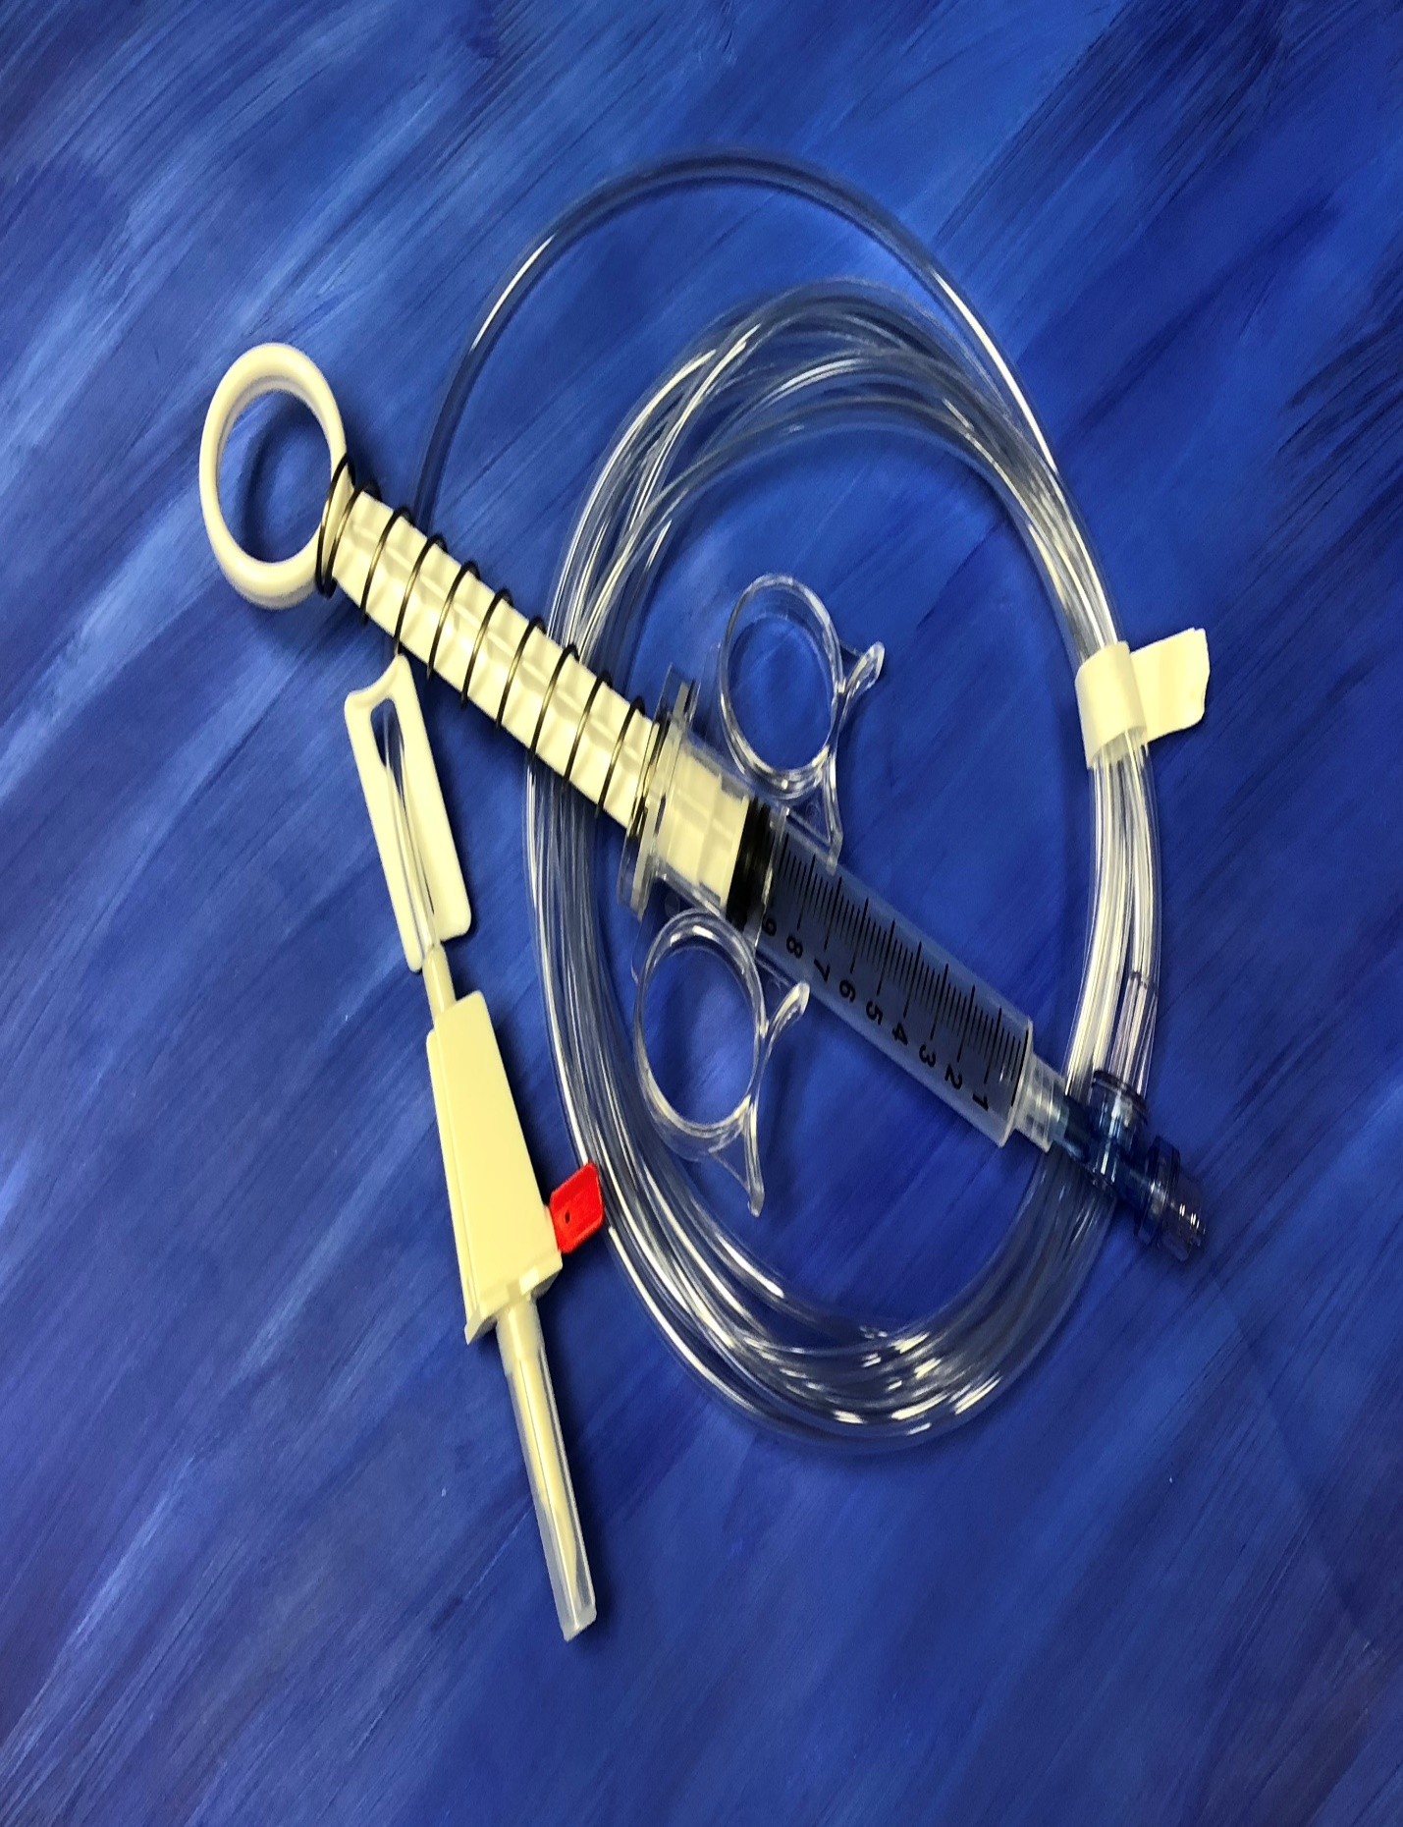

#2
CMS-150

Coiled Injection Line

Bill of Materials Quantity

T0049-C 72” coiled line with connectors (0.60” x .122”) 1
A0049 4*9 pouch with polysleeve back 1

100 lines per case

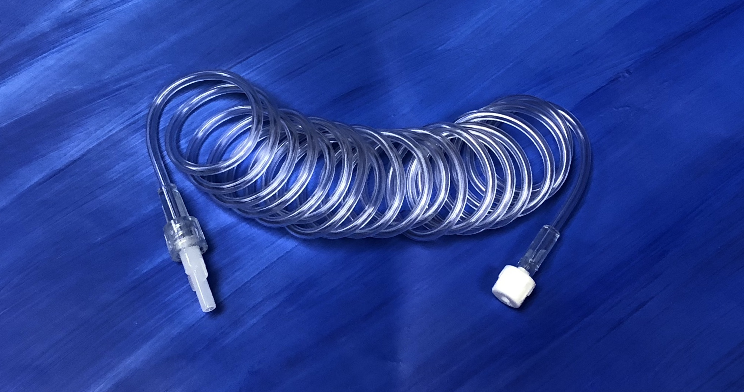

#3

CMS-1212

Single spike tumescent set without chamber

Bill of Materials Quantity

1212NSA (Standard IV tubing with Silicone Pump-header) 1
A0045 10 x 15 pouch 1

25 sets per case

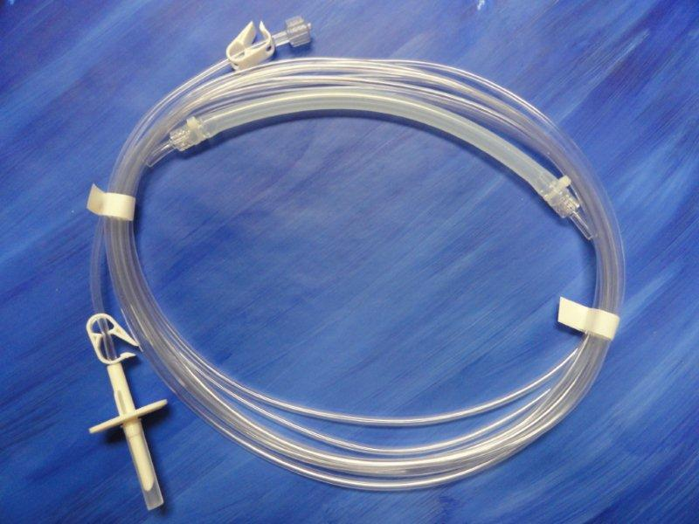

#4

955V

Skytron Urology Drainage bag

Bill of Materials Quantity
Skytron Operating Table Drainbag 1

20 drain bags per case

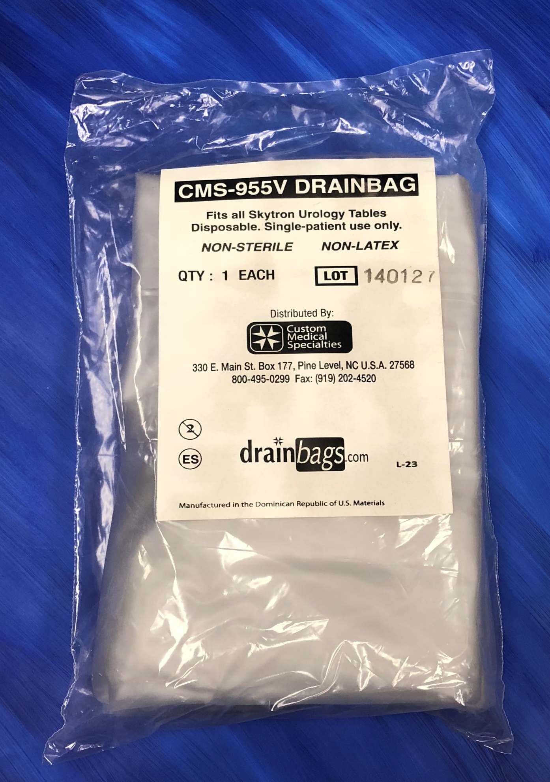
#5

954P

GE/OEC 2600/2800 Drainage Bag

20 drain bags per case

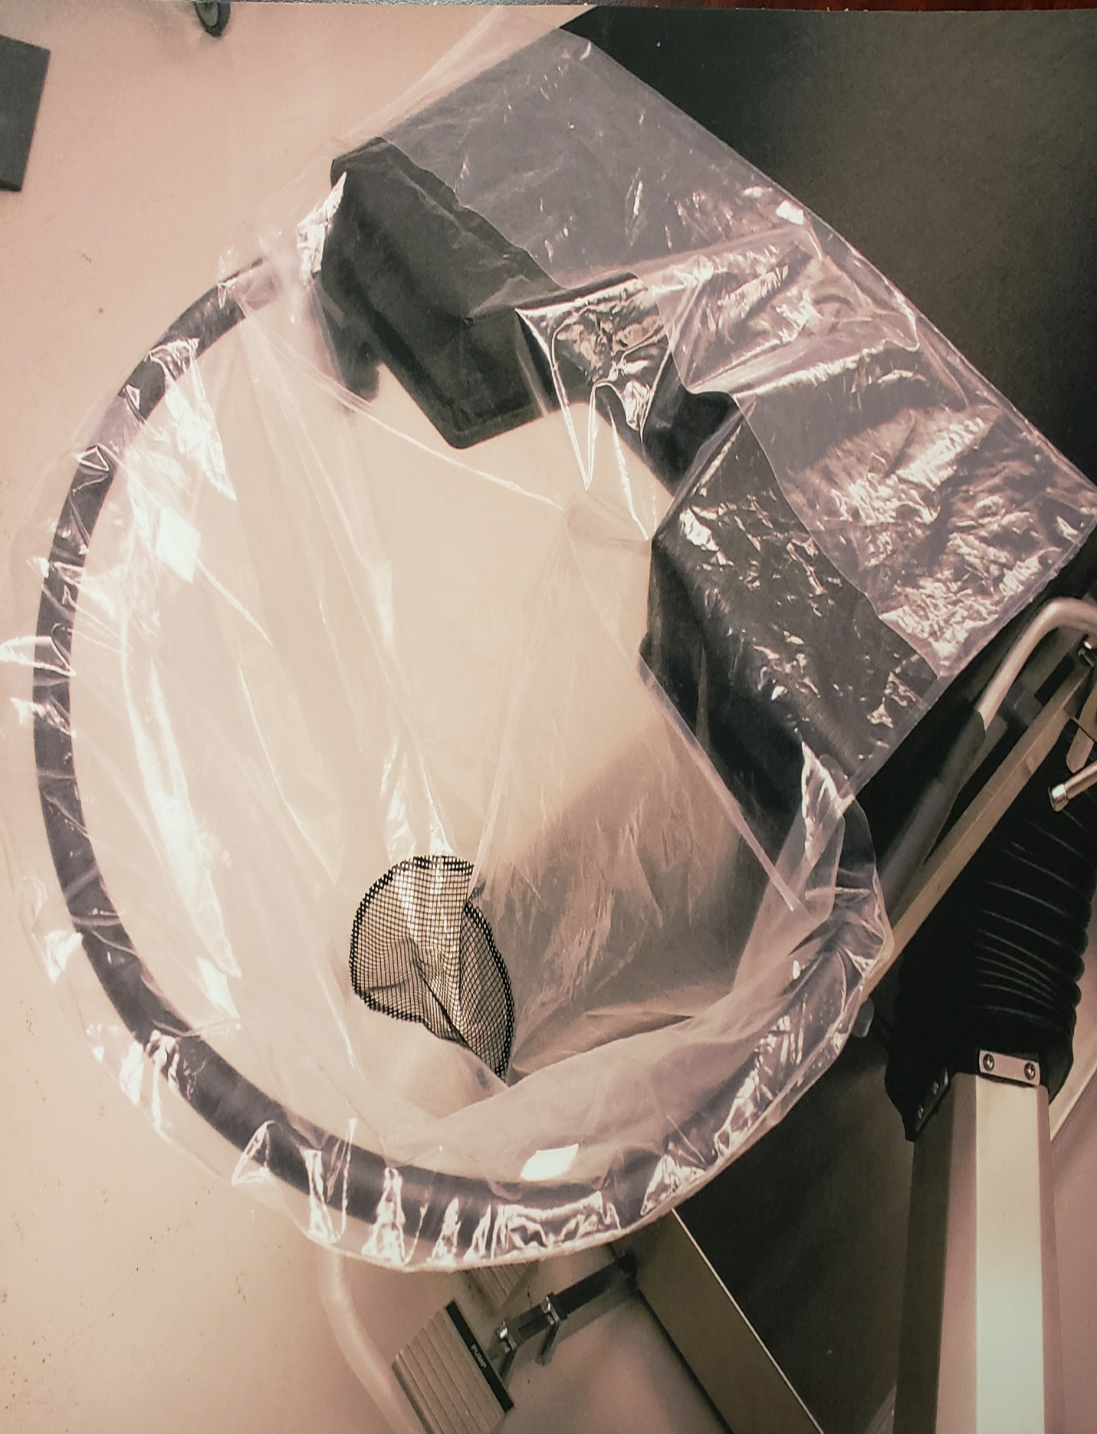

#6
CMS-151

Coiled Injection Line

Bill of Materials Quantity

T0049-C 72” coiled line with connectors (.060” x .122”) 1
A0049 4*9 pouch with polysleeve back 1

100 lines per case

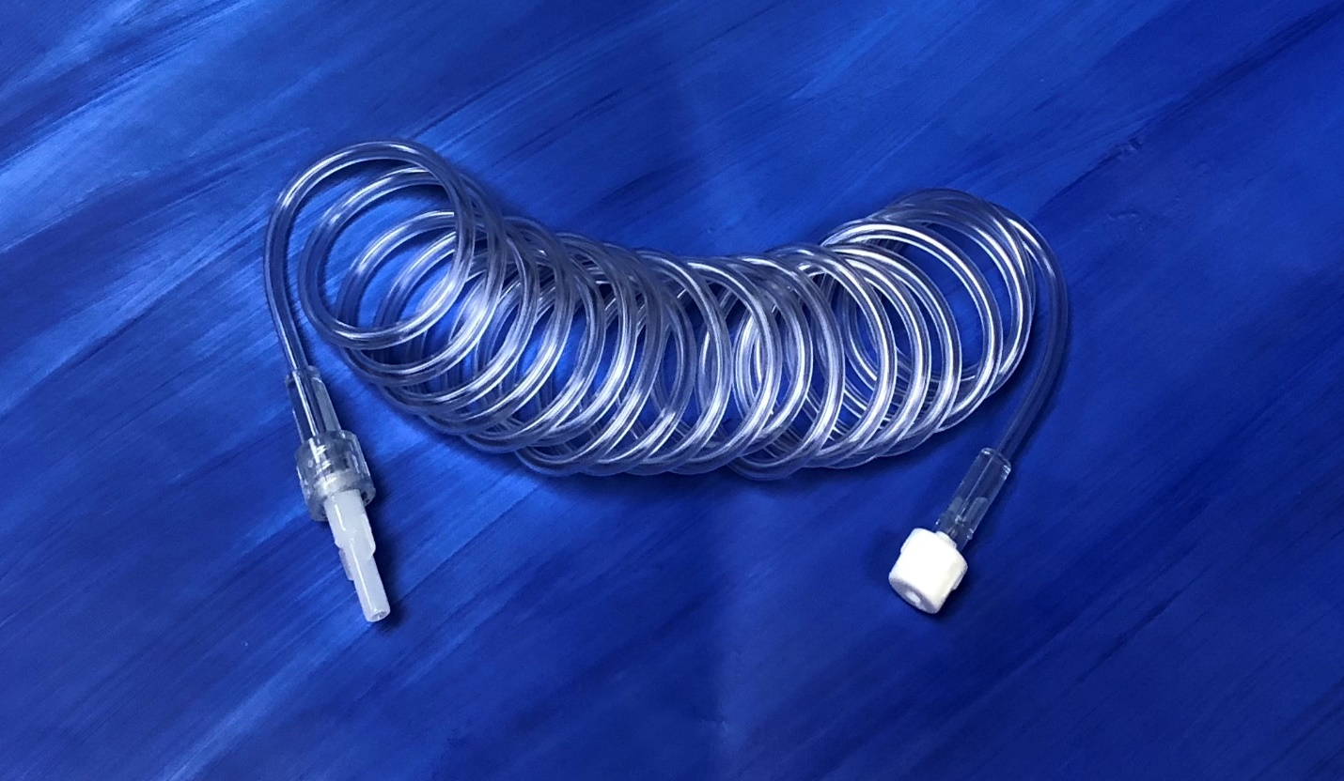

#7
CMS-1228

Bubble (Transition) Tubing

Bill of Materials Quantity

T0186 Bubble tubing (Transition) 108” length (1)
A0045 10 x 15 Chevron peel pouch (1)

10 sets per case

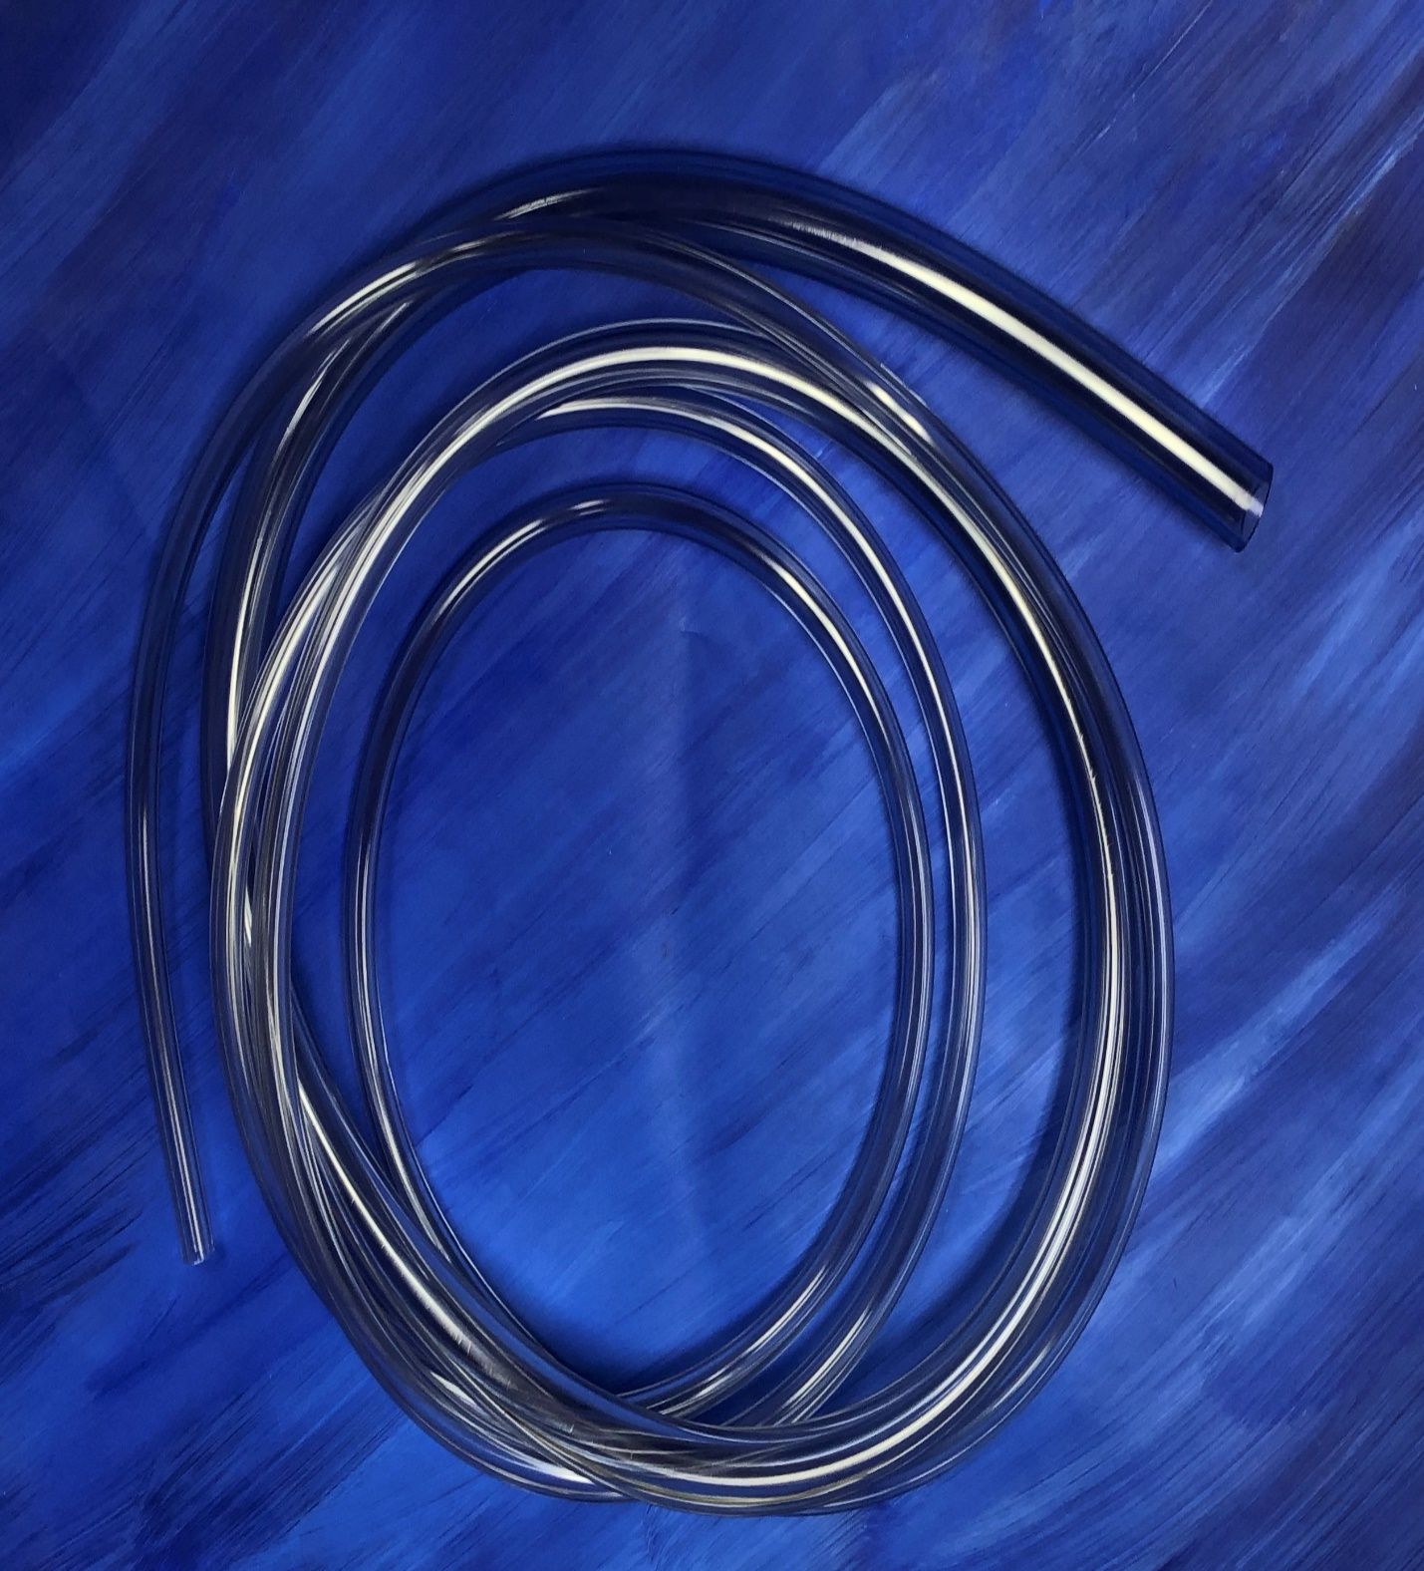

#8

CMS-6025

Soak em’ up pad

Bill of Materials Quantity

A2939 32” x 36” Absorbent pad 1
A0045 10 x 15 Chevron peel pouch 1

25 per case

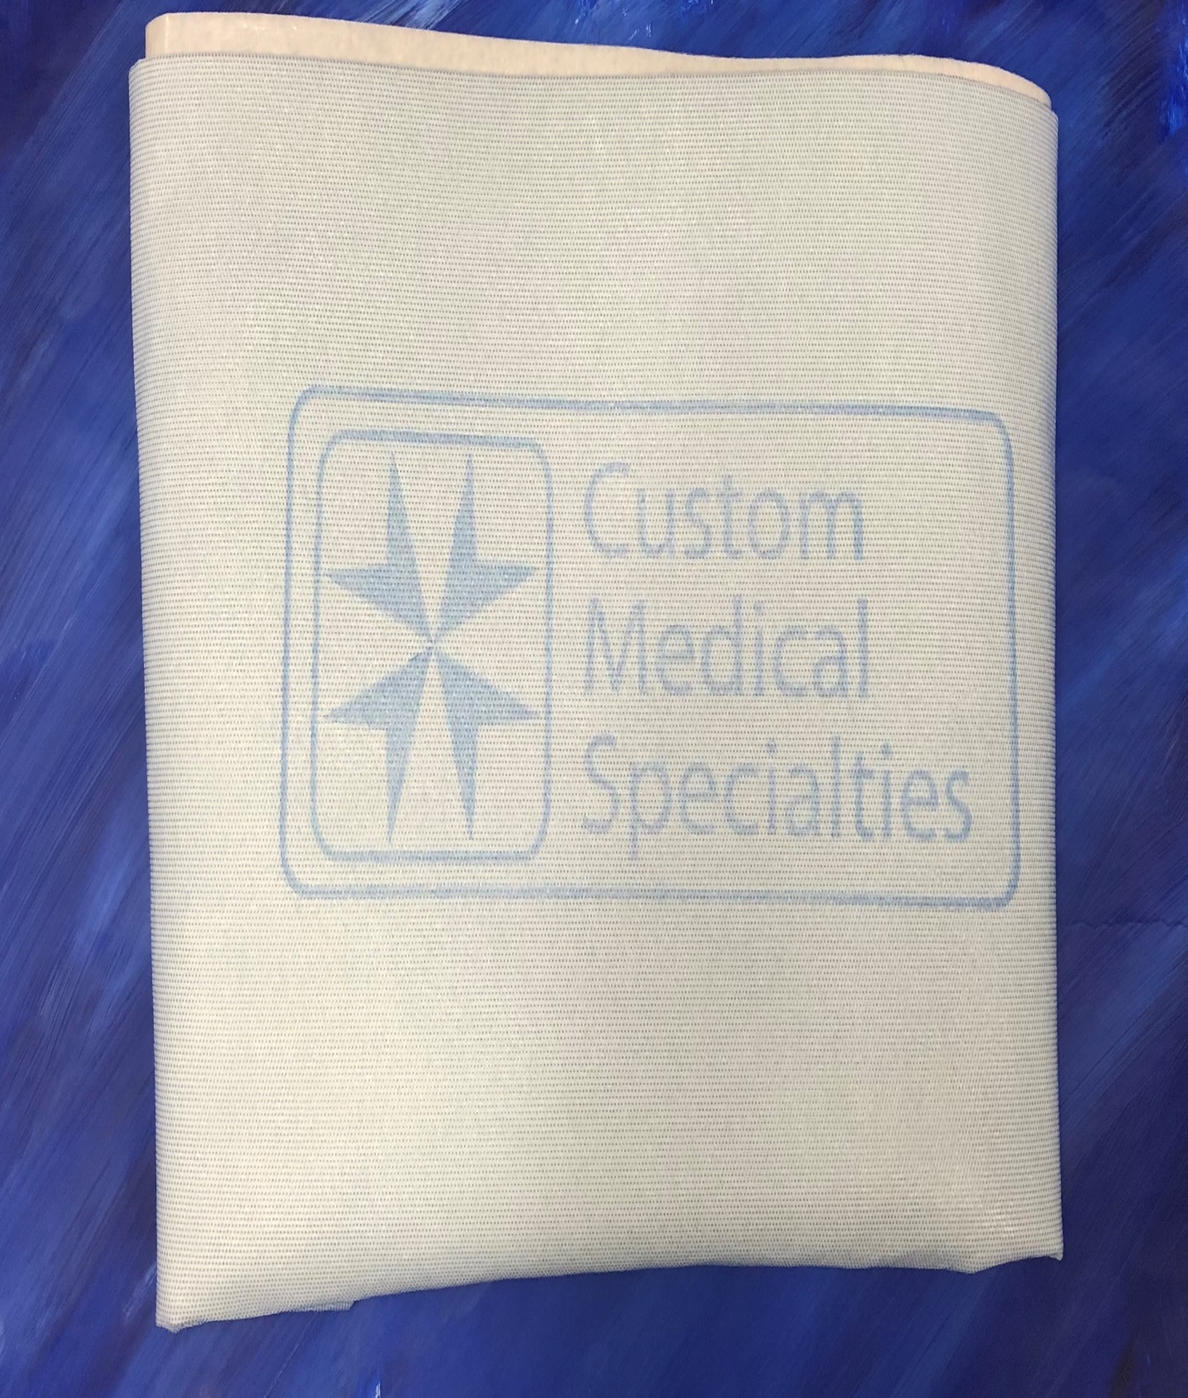

#9

CMS-3628BB

Band Bag

Bill of materials Quantity

A0712 Bandbag 36 x 28 1
A0050 8 x 12 Tyvek Chevron Pouch 1

50 Band bags per case

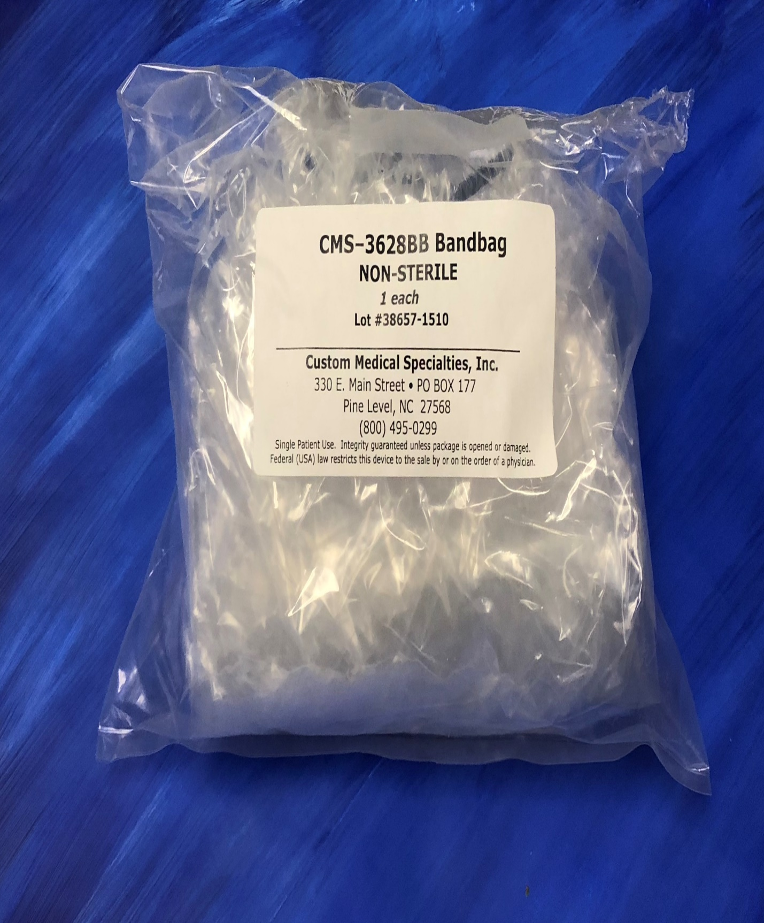

#10

CMS-655
Wide Foot Switch Cover

Bill of Materials Quantity

A0307 Bag, Draw cord 24” x 19” 1
A0027 6 x 10 Poly Bag 1

100 bags per case

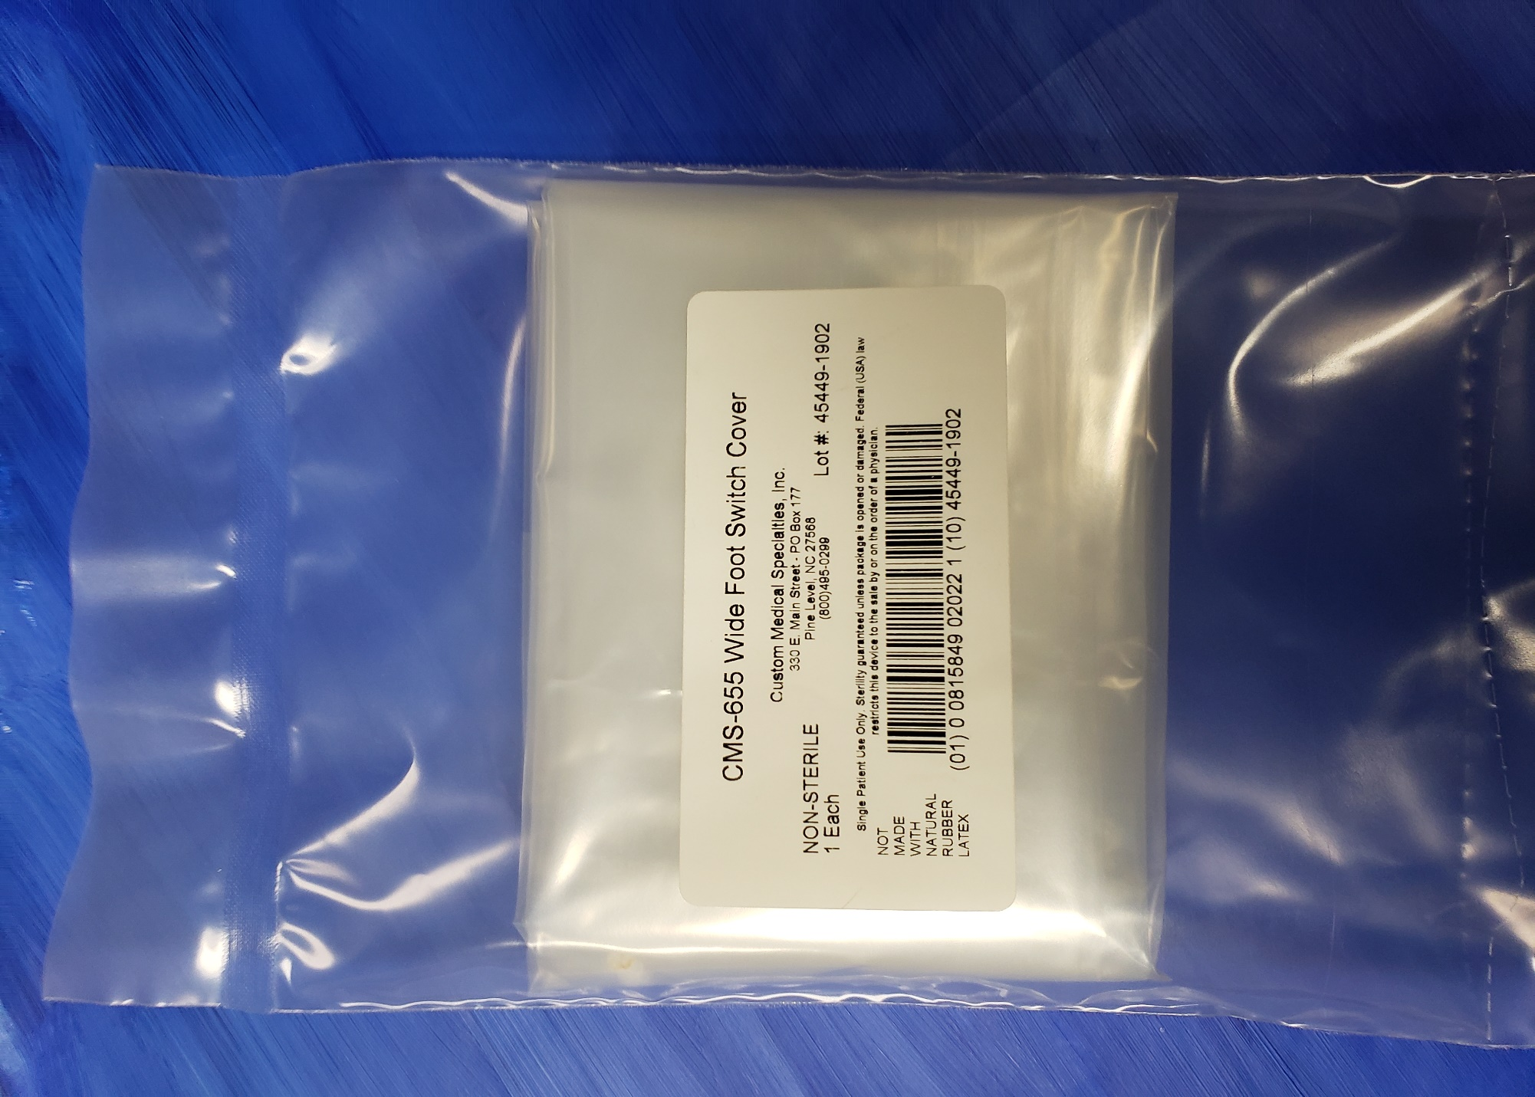
#11

CMS-1637

Sharps Collection System

Bill of Materials Quantity

1637 NS Cup with charcoal foam 1
A0044 6 x 10 Tyvek Chevron Pouch 1

25 cups per case

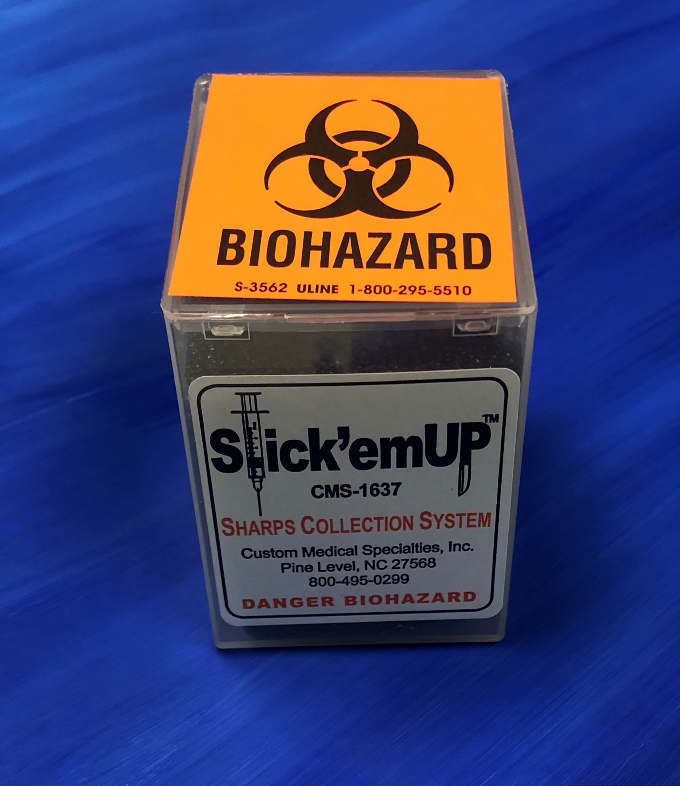

#12

CMS-510

Stop ‘N FLO Collection Container

Bill of Materials Quantity

M0682 15 Liter collection container 1
M0683 Spigot assembly and cap 1

10 containers per case

CMS-515

Same set with solidifying powder

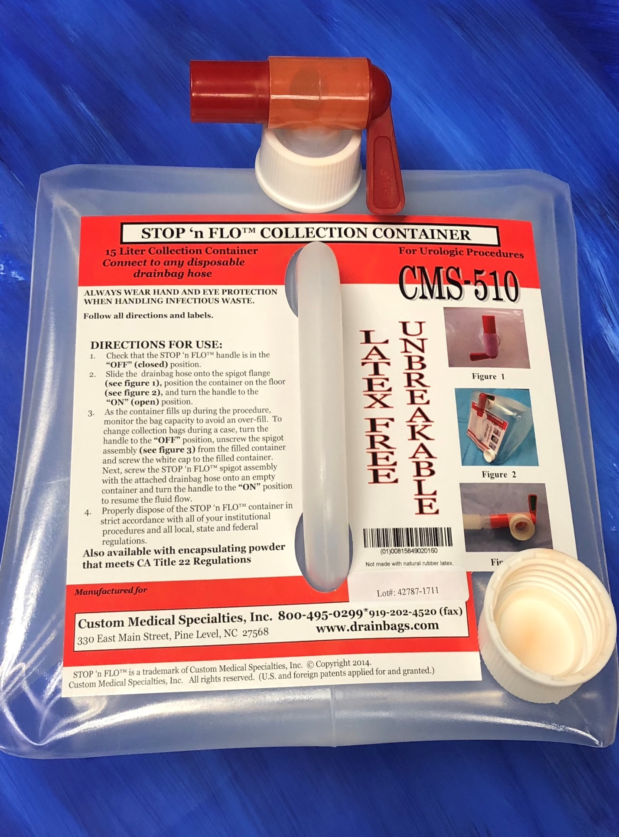
#13

CMS-851

Fistula/PICC drape

Bill of Materials Quantity

A0319 32 x 28 Fenesrated Absorbent Drape 1
A0094 Quick-Tear Header Bag 1
A0142 Medical CSR-wrap 30” x 30” 1

10 drapes per case

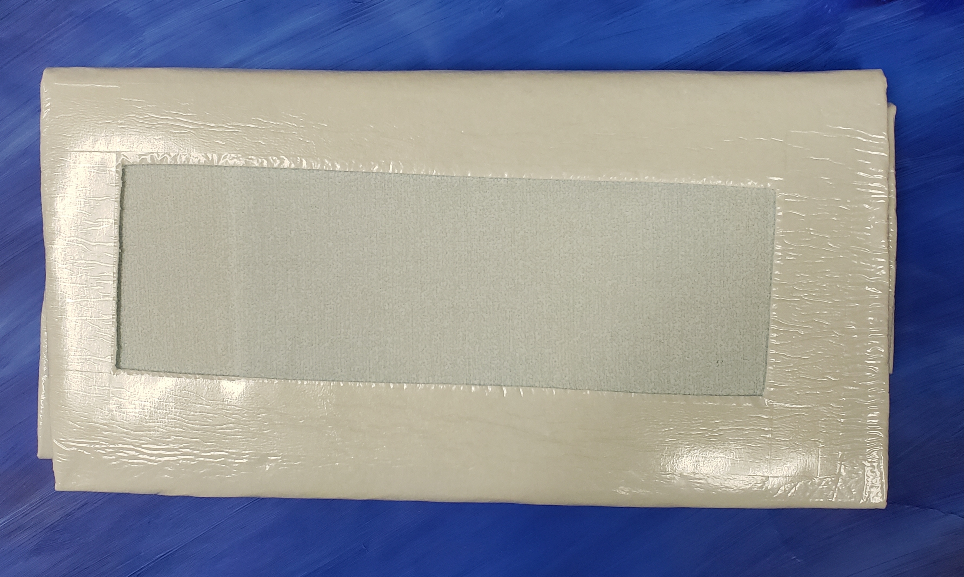

#14

CMS 951 V-8

Liebel Flarsheim Table Drainbag with 8mm Adapter

Bill of Materials Quantity

CMS-951V Drainbag 1
CMS-608 8mm adapter plug 1
A1931 12 x 12 2-vented clear LD poly bag 1

20 drain bags per case

#15

CMS-1622

Coiled Y-connector pack

Bill of Materials Quantity

M0077 Universal Cap, White 1
M0071 Universal Cap, Blue 1
T0195-CH Y shaped connector tube (Standard IV Tubing) 1 (98.42” length)
A0044 Tyvek Chevron Pouch 1

50 sets per case

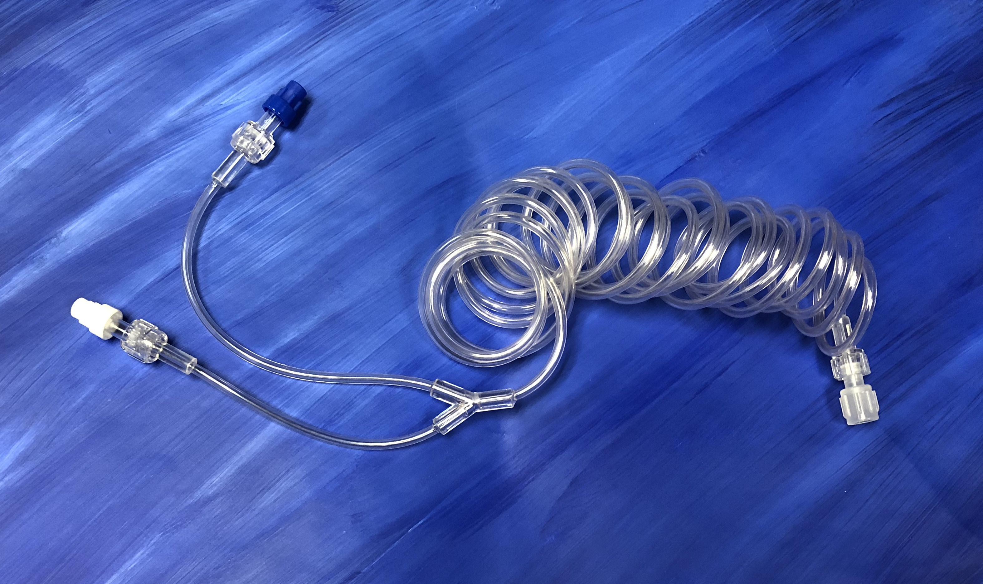
#16

CMS-1335

Luer Slip Extension Line

Bill of Materials Quantity

T0047 .060” x .122” 20” length (1)
M0295 Male L Slip for .125 Tube 1
M0081 Female Luer Lock 1
A0049 Pouch 1

#17

CMS-999
Universal Drainbag

Bill of Materials Quantity

Vinyl-Acetate Drainbag 1

20 per case
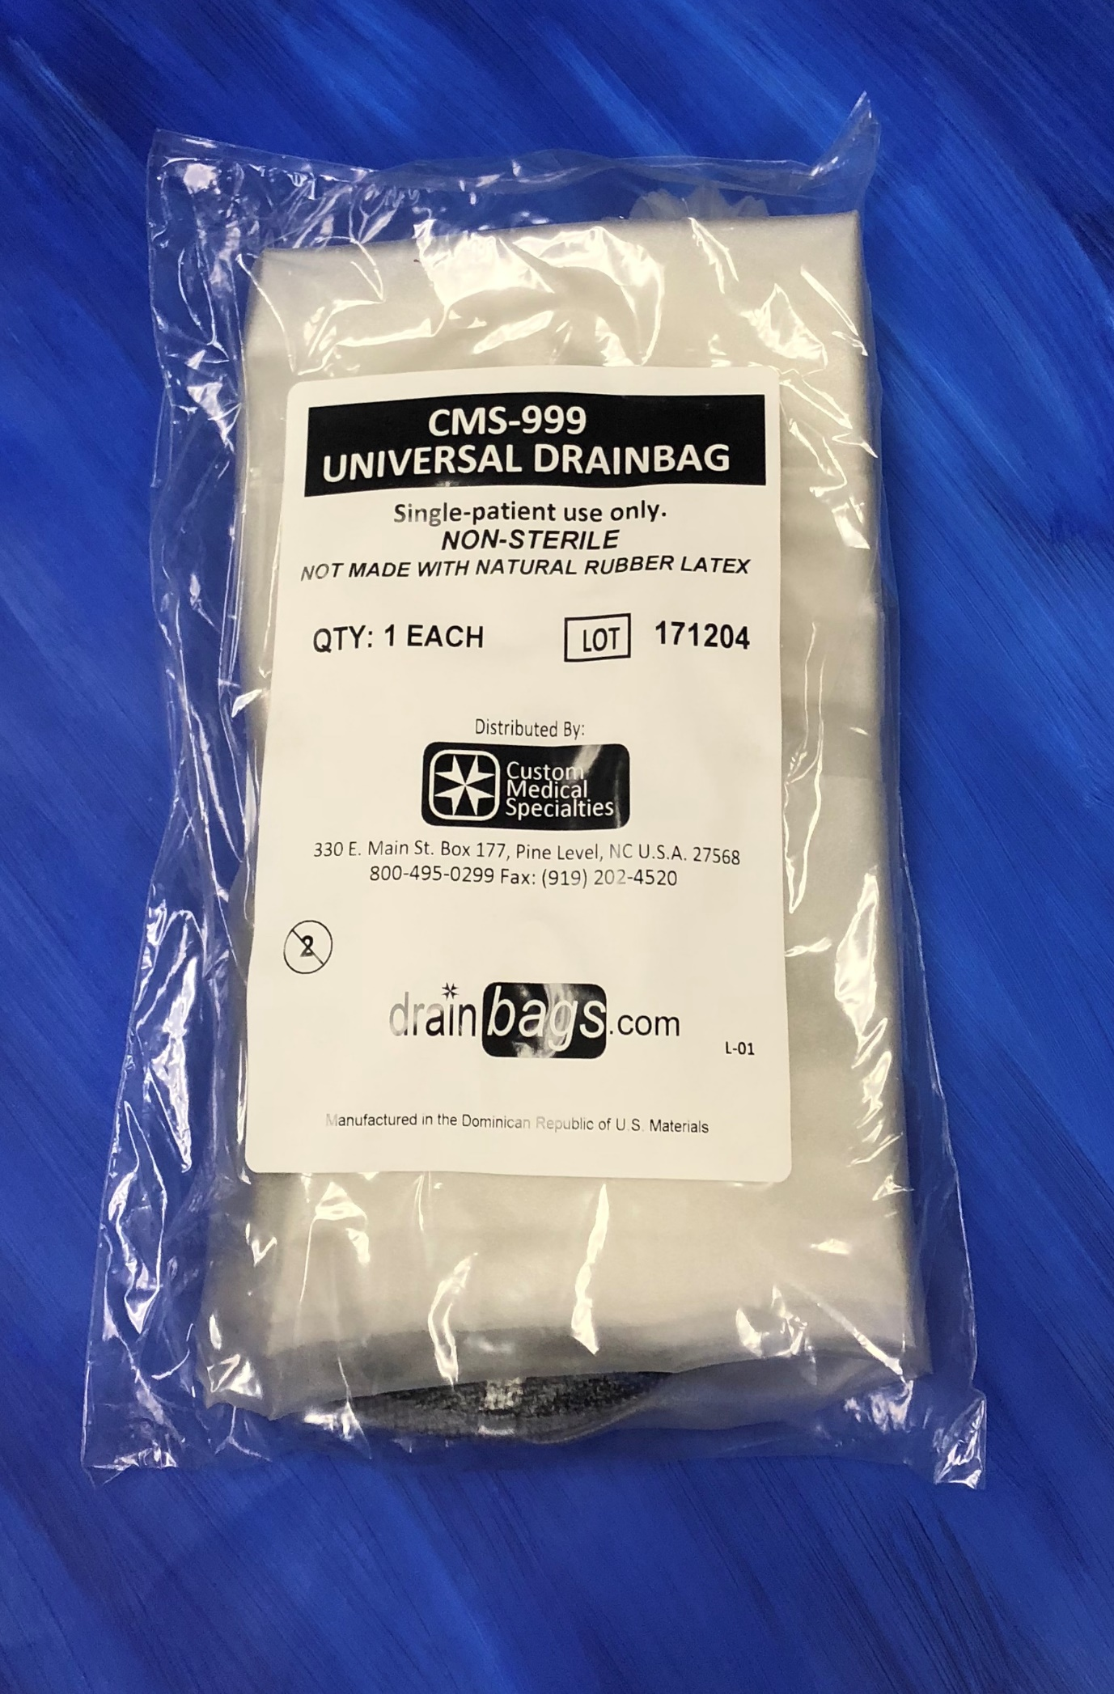

#18

CMS-1211
Single-Spike Infiltration Tubing w/ Drip Chamber

Bill of Materials Quantity

1211-NSA (Standard IV Tubing) 1
Silicone Pump-header 1
Thumb Clamp 1
10 x 15 pouch 1

25 per case

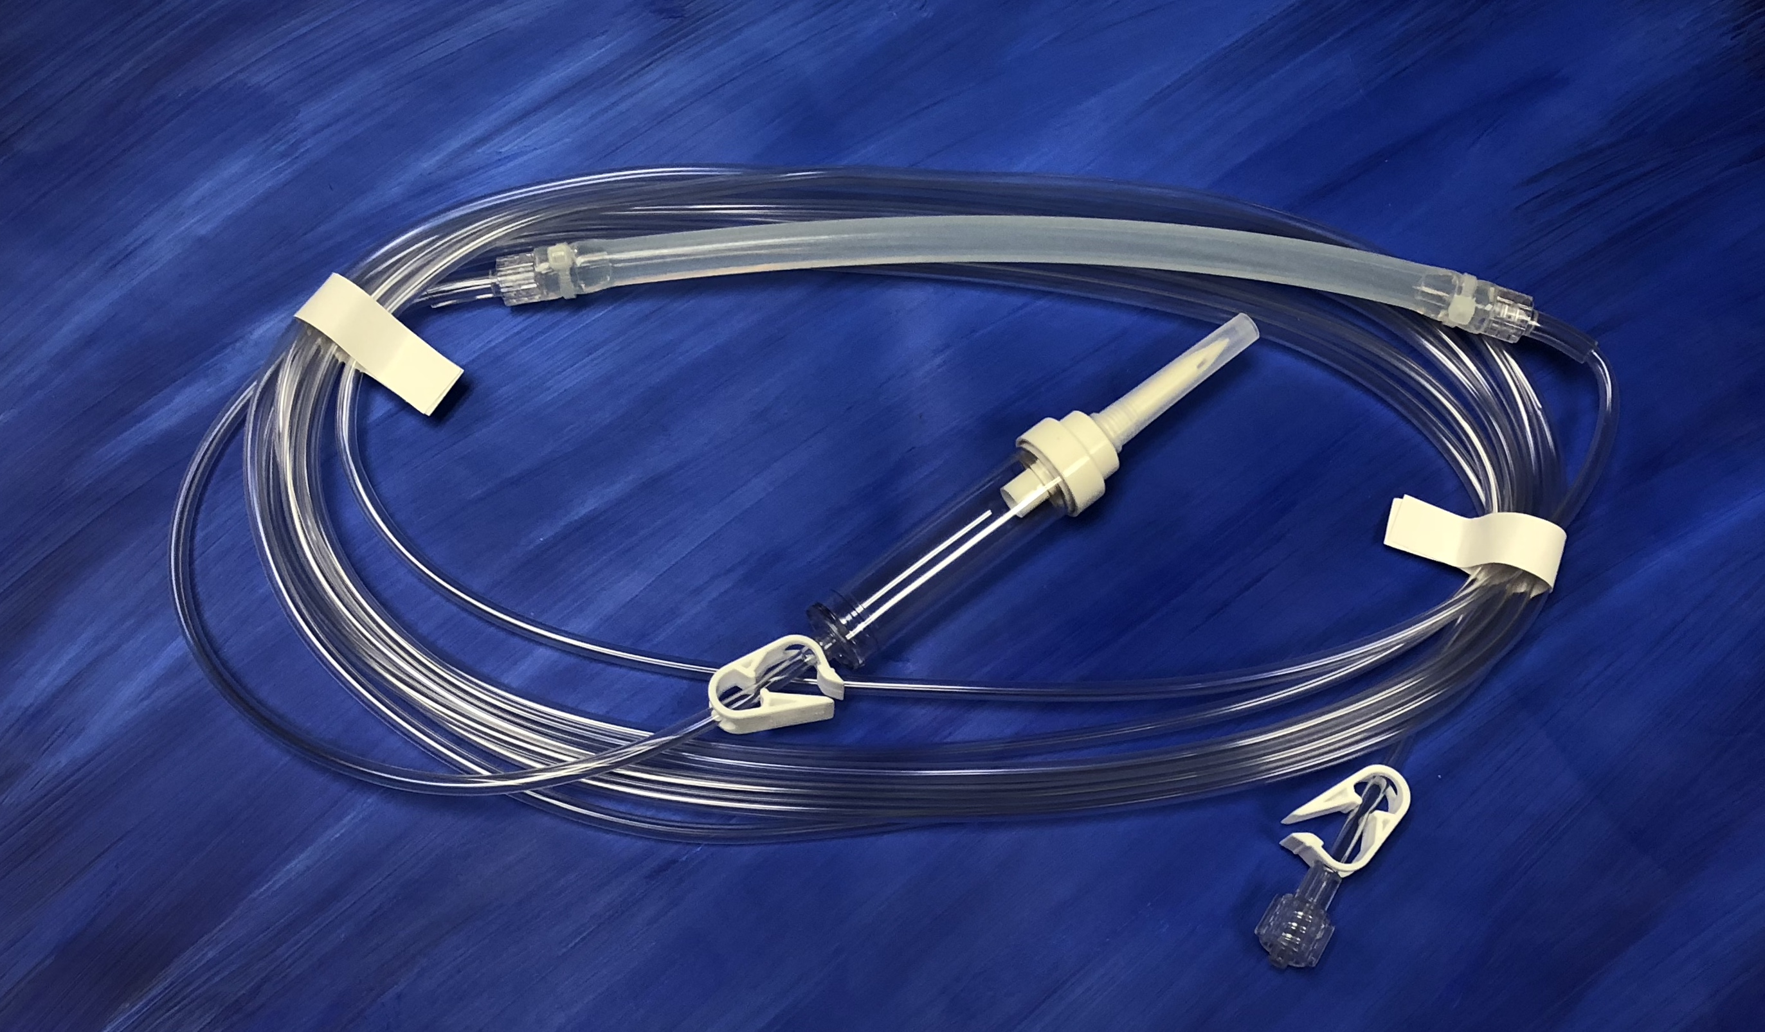
#19
CMS-1222
Custom Flush and Disposal System

Bill of materials Quantity

1500 ML waste bag -printed 1
Male luer lock cap vented 1
High crack dual check valve 1
Universal spike vented L86 1
White mini-pinch clamp 1
Galt tubing .158 x .218 144” (1)
Eastern Commodities 5” x 4” sleeve 1

100 per case

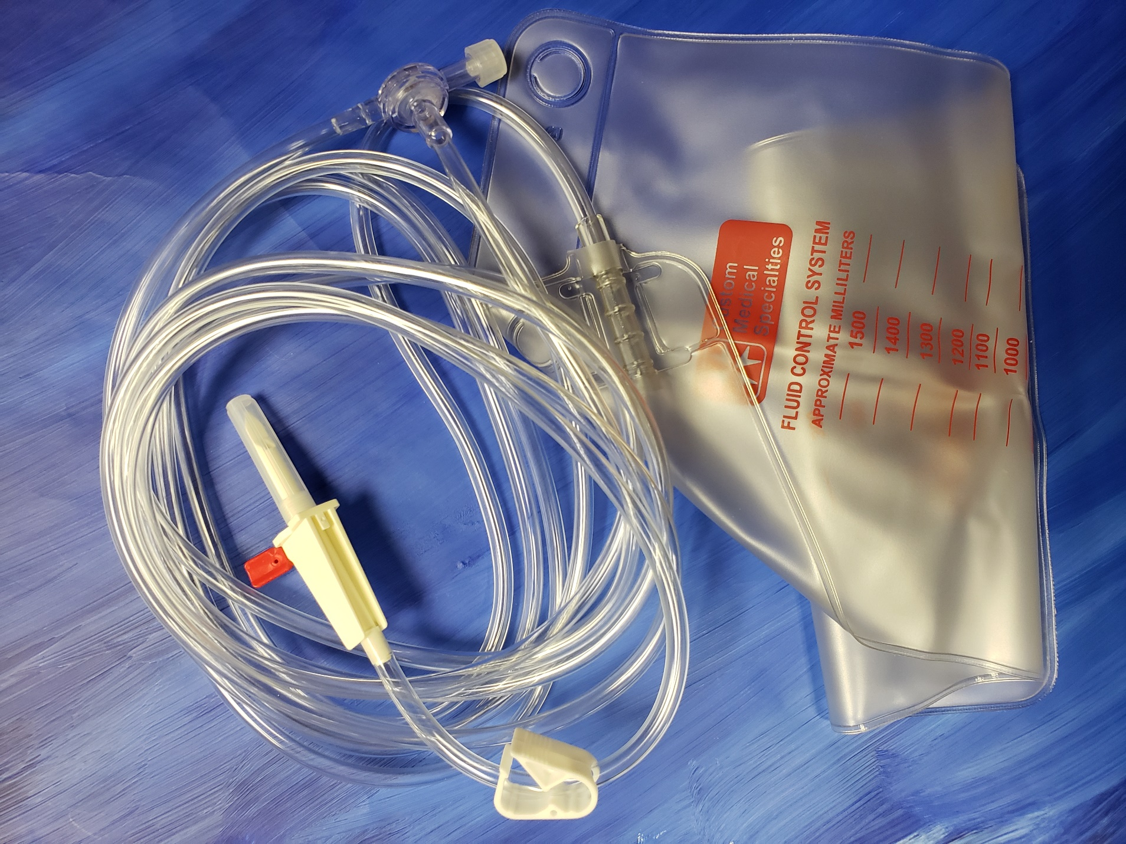

#20

CMS-1113
Contrast Transfer Set

Bill of Materials Quantity

.114” x .159” Tubing 19”
Universal Spike Vented L86 1
Swabable valve with male luer 1
Female luer lock connector .160” ID 1
6” x 10” Tyvek Chevron Pouch 1

100 per case

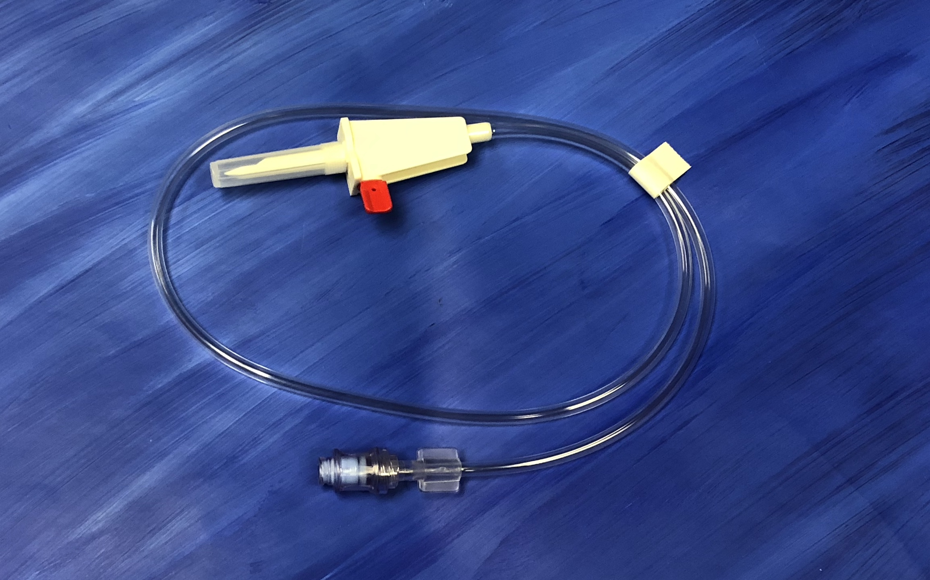
#21

CMS-608
6mm Adapter plugs

Bill of Materials Quantity

8mm reducer plug 22mm OD x 8mm OD 1

50 per case
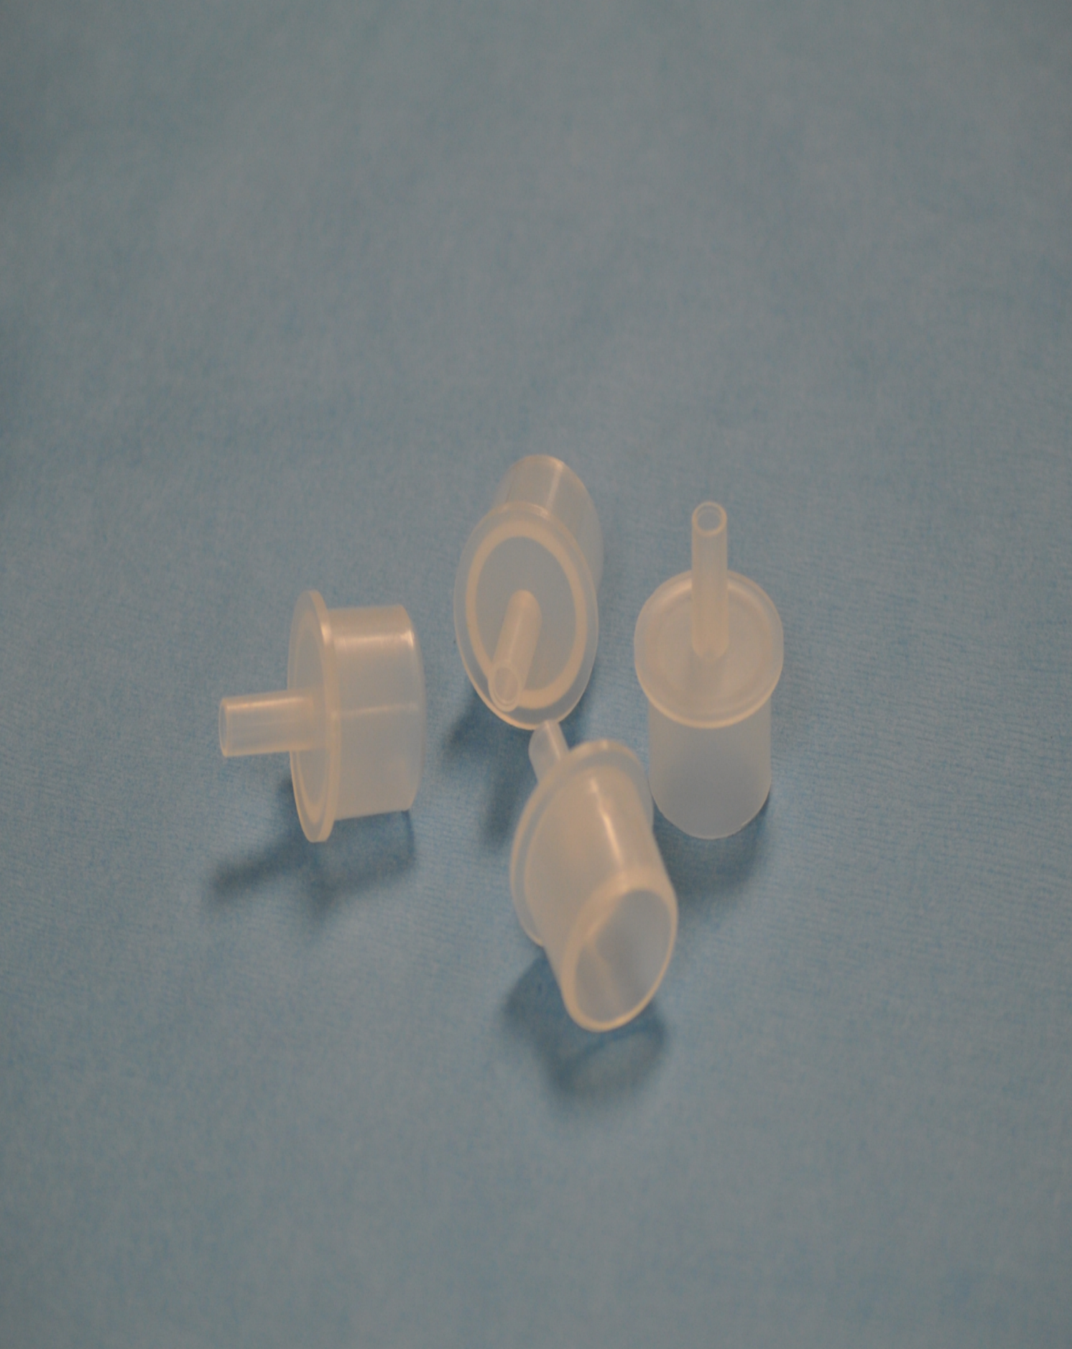

# 22
CMS-1213
Large Bore Infiltration Tubing

Bill of Materials Quantity
Infiltration Tube (.201” x .380”) 1
Silicone Pump-header 1
Bag Spike 1
Thumb Clamp 1

